Flow Control and Looping
The general Python syntax for a simple if statement is:
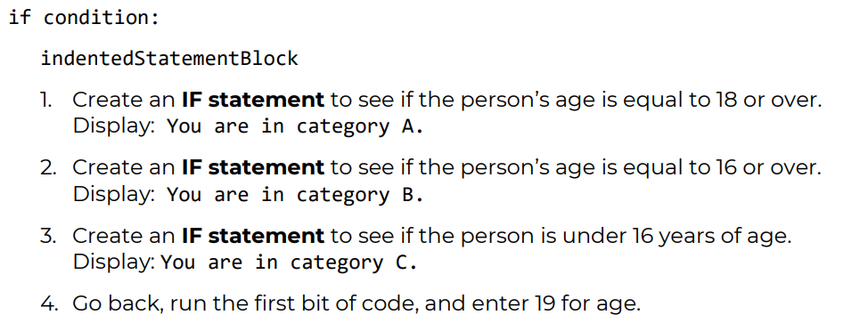
As you see, there are too many confusing messages!
Simple IF statements work fine, but not in a chain of IF statements such as these. For a chain, we need to use an if…elif statement.

5. Create an if…elif statement to examine the age in one statement.
Follow this pattern:
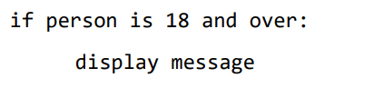
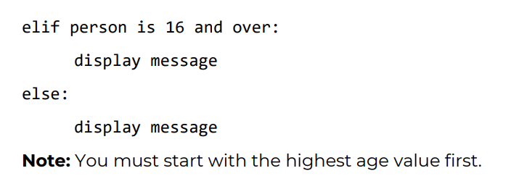
Note: You must start with the highest age value first.
6. Save and rerun your code using different values for age.

While Loops
The syntax of a while loop in Python programming language is:
while expression:
statement(s)
1. Create a variable with the value 1.
- Write a while loop that starts at 1 and ends at 100.
- Within the while loop calculate and display each number and its square.
- End the loop if that square is bigger than 2000.

Investment
1. Calculate how many years it will take an initial investment of £100 to
grow to a target value of £1000 if the interest rate is 10%.
Tip: Don’t start writing code until you’ve got a plan of action!
Make your calculation easier to understand by defining the following
variables:
• Initial investment
• Target value
• Interest rate

Solutions in ‘Flow Control Solutions.docx’

